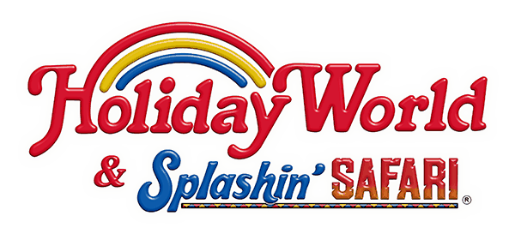

FYM

Frassati Youth Ministry

Holiday World
Thursday
July 19, 2018

PERMISSION FORM

The Youth are going to Holiday World
-For 7th through 12th graders (as of this fall) of all three parishes
-Departure will be from St. Mary’s at 8:30 am
-Return will be around midnight to St. Mary’s
-Cost of the ticket to get into Holiday World is $35.00 payable by youth
send cash or check (made out to St. Mary’s) with this permission slip
-Each youth will be responsible for their own drinks and meals
-Adult chaperones over the age of 21 are needed
(Must have completed the Safe and Sacred Program)
Call the Parish Office (346-3604) to volunteer

I/We, the parents of _____________________________________________________
request that the Jennings County Catholic Youth Ministry allow our son/daughter to participate in the Holiday World Trip. I/We hereby release and save harmless St. Ann’s, St. Joseph’s and Mary’s Catholic Church and any and all of its employees and volunteers from any and all liability for any and all harm arising to our son/daughter as a result of this trip. I/We, the undersigned have read this release and understand all its terms and execute it voluntarily and with full knowledge of its significance.
In the event of an emergency, please call me at ______________________________and if we cannot be contacted, we hereby authorize that emergency treatment may be administered.

Parent Signature __________________________________________Date _______________

Parent Signature __________________________________________Date _______________

The following are special circumstances regarding my child of which you should be aware:

PERMISSION FORM MUST BE TURNED IN
BY NOON ON MONDAY, JULY 16TH

